**Working Prototype Template**

**Bugs / Improvements / TODO:**

* Saving listings functionality not implemented
* ProfileUserView doesn’t update profile’s Listings until restarting the app (refreshing the user).
* Change / Forgot username/password not implemented
* No email auth
* Refresh icon not showing sometimes
* Rating doesn't show up on the profile view in messages
* .leading, .trailing padding is different in CategoryPicker(): View
* Delete account does not show error alert when account deletion is unsuccessful.
* Delete account does not delete the postings that that user made
* UI is not perfect on older phone models on profile view. This issue arises with the smaller phones that still have the physical home button
* Edit Profile view ui covered when typing in text fields. It is inaccessible until you press return on the keyboard
* (I’m not experiencing this issue -Dillon) To see anything in users message view the person you have messaged must respond. Then the conversation will appear in the chat view

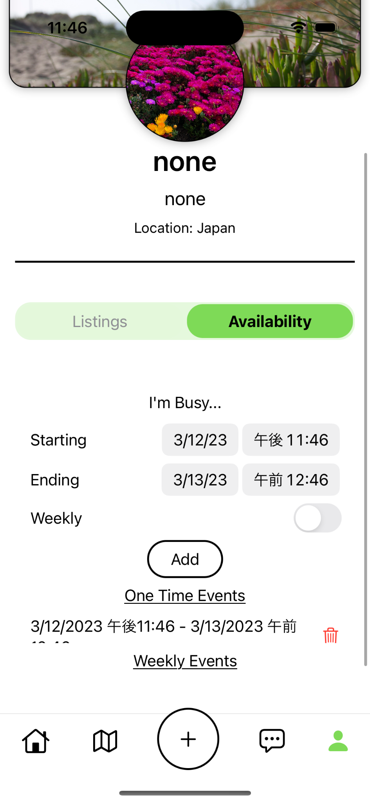

* ^ Calendar UI Improvements: 1) Weekly events list becomes too small; 2) Display one time event (One time event is being scrollable while the weekly is not)